Revelations 17
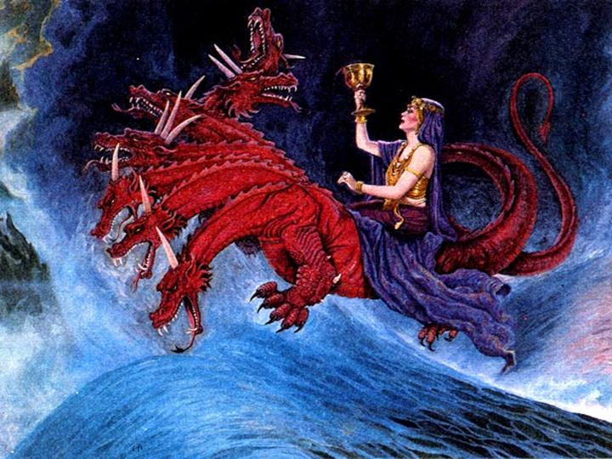
Religious Babylon’s Fate

Verses 1-6, The Adulterous Woman.
- The counterfeit who controls kings.
- False worship that enriches itself.
- First empowered by world government.
Verses 7-14 The Woman Exposed.
- References: Martin Luther, Werke, Erlangen edition, vol. 24, p. 294; vol.15, p. 276.
- Ibid. Werke, vol. 59, p. 284.
- William McGrath, Anabaptists: Neither Catholic nor Protestant, http://www.pbministries.org/History/William%20R.%20McGrath/the_anabaptist.
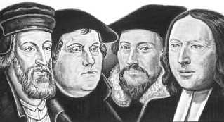
- John Christian, A History of the Baptists, Vol. 1, chap. 15.

- J.J. Stockdale, The History of the Inquisitions, 1810, pp. xxviii, xxix.
Verses 15-18. The Doom of the Woman.
- The doom is mid-tribulation.
- Those who attempt to leave her do not go far enough. Reference, Sardis: Revelation 3:1-6).
- The true Church of Jesus Christ has never sought political power, but historically sought the doctrine of Liberty; the separation of Church and state. John 18:36.

Revelations 18
The Fall of The Economic and Governmental Babylon

Verses 1-2 The Fall of the City Proclaimed.
- Isaiah 13-14 and Jeremiah 50-51 indicate the city of Babylon will be rebuilt.
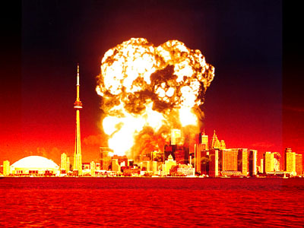
- Isaiah 13:19-20.
Verse 3. The Sin of the City.
Verses 4-8 “Come out from her.”
- Who? Deuteronomy 4:30-31.
- Confidence is destroyed. (Tower of Babel again? Genesis 11:1-9).

Verses 9-18. The center of society.
- World Government flows from Babylon, so the rulers mourn.
- World commerce and the economy is dependent upon this city.

- Slaves. May not be actually slavery, but the deception that steals souls from God. Enslaves mankind.

- The ones who weep over this woman rejoiced over the fall of the other.
Verse 20-24. The contrast in Heaven.
- Who is this bridegroom and bride?
- This marks the end of the Tribulation.

