Revelations 16
The Seven Bowls of Wrath
- Introduction. 7 Bowl end the tribulation, but reveal God’s full wrath.
- Revelation 14:6-7.
Verse 1 - The command.
- “The great tribulation” of Matthew 24:21.
- Literature or figurative.
Verse 2 - The first bowl and boils (cancer?).
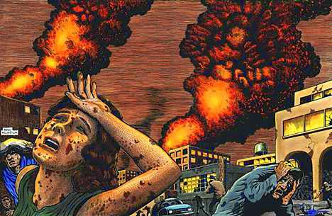
- The Antichrist (now Satan himself) is being worshipped and this plague is poured upon those worshipers.

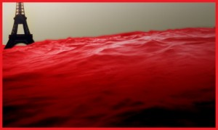
Verse 3 – The second bowl and the oceans.
- The importance of the seas and oceans.
- God does not plan to clean this world, but recreate it.

Verses 4-7 – The third bowl and justice.
- The importance of water…
- A message for today.
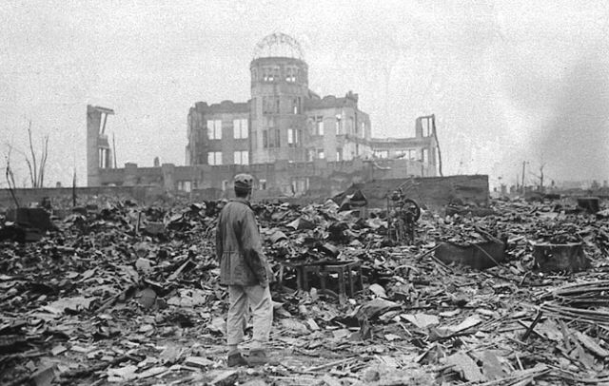
Verses 8-9 – The fourth bowl and world reaction.
- Reference: Matthew 16:23-24.
Verse 10-11 – The fifth bowl of darkness.
- World-wide, or in Babylon?
- The people’s trust goes dark. Amos 5:18, Nahum 1:6,8, Zephaniah 1:15, and Mark 13:24-25.
- The longevity of these plagues.
- The people’s response.
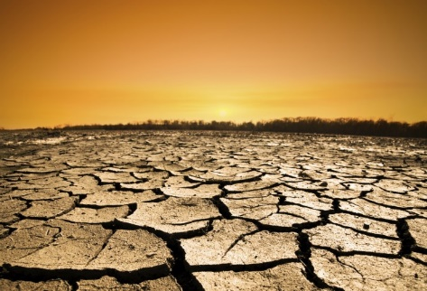
Verses 12-16 – The sixth bowl and preparation for the battle.
- Two contents 1) the drying up of the Euphrates, and, 2) the deception of demons to gather the armies in Armageddon.
- The world is united to destroy Israel.
- References: Judges 4:15, Judges 7, and 1Samuel 31:1-13.
- The encouragement. Who is it for? Matthew 24:40-42.
Verses 17-21 - The seventh bowl and the end.
- Earth is decimated.
- Hailstones fall to kill men.
- The first three Commandments: 1) have no other god, 2)make no idol, 3) do not misuse the name of God.
