Revelations 15
The Wrath of the Lamb; The Beginning of the End
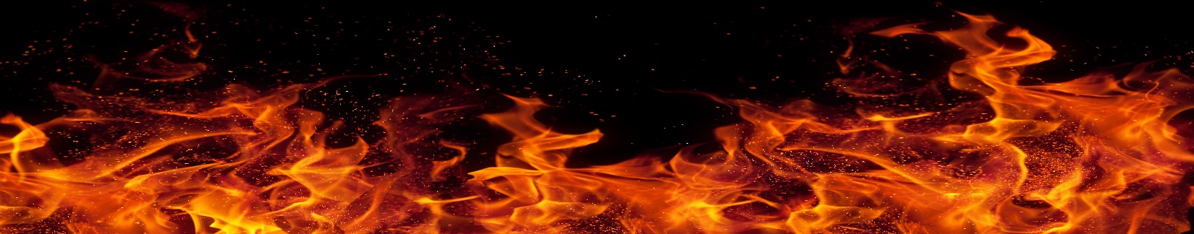
- The Wrath of God.
Verse 1. The End of God’s Wrath begins.

- “Another sign” adds to the two “signs” in Chapter 12.
- Today’s gospel contains God’s Wrath and His Grace. Romans 6:25.
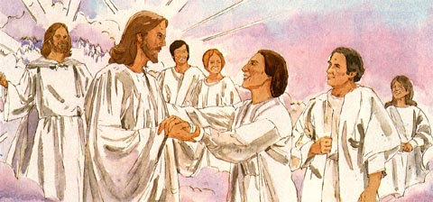
Verse 2. The Harvest Completed?
- The significance of the harps.
- What is meant by “overcame”? James 1:12, Revelations 2:10.

- The Crown of Life is special.
Verse 3-4. The Song of Moses.

- Exodus 15:1-18.
- Jesus is God.
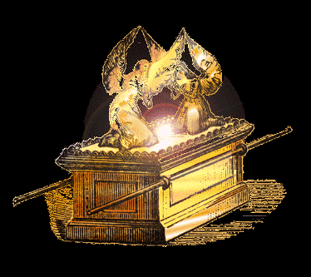
Verse 5. The Real is Revealed.
- God is Faithful.
Verse 6-8. The Beginning of the End.
- About “seven” and these angels.
- Why the smoke?
