Revelation 14
144K, Three Warnings and God’s Wrath
- The middle of the Tribulation pause is found from 11:16 through 15:4.
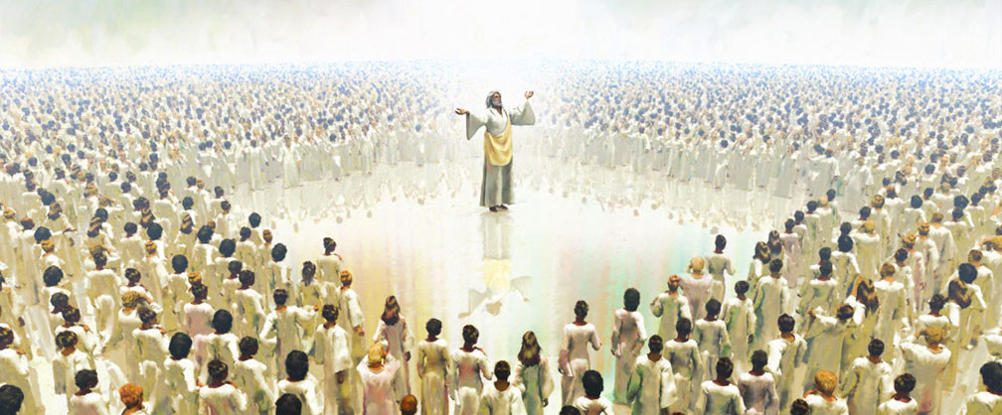
Verses 1-5. The 144K Special Servants.
- Redeemed, first fruits, virgins.

- Reference: Hebrews 13:4.

- Another view.
Verses 6-7. The Warning with Grace.
God never brings judgment without proper warning.

- The hope: I Corinthians 15:3-4.

Verse 8. The Fall of World Religion.
Verses 9-11. Warning without Grace.
Verses 12-13. Those Who Remain Faithful.
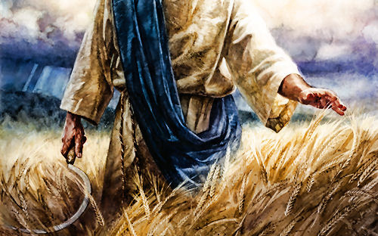
Verses 14-20. The Coming Harvest.
- The Wrath of the Lamb is the second half of the Tribulation.

